**ME424 Project 2 Report**

**11912404 江轶豪**

1. **Full state space model:**



where 



1. **Angle dynamic model:**



1. **Linearized model for angle dynamics:**

, where

1. **Discrete Time Angel Dynamics Model:**

****

1. **Drake Simulation Setup and Testing**

Initial state vectors are shown as below:



All snapshots shown as below are the simulations with no disturbance.



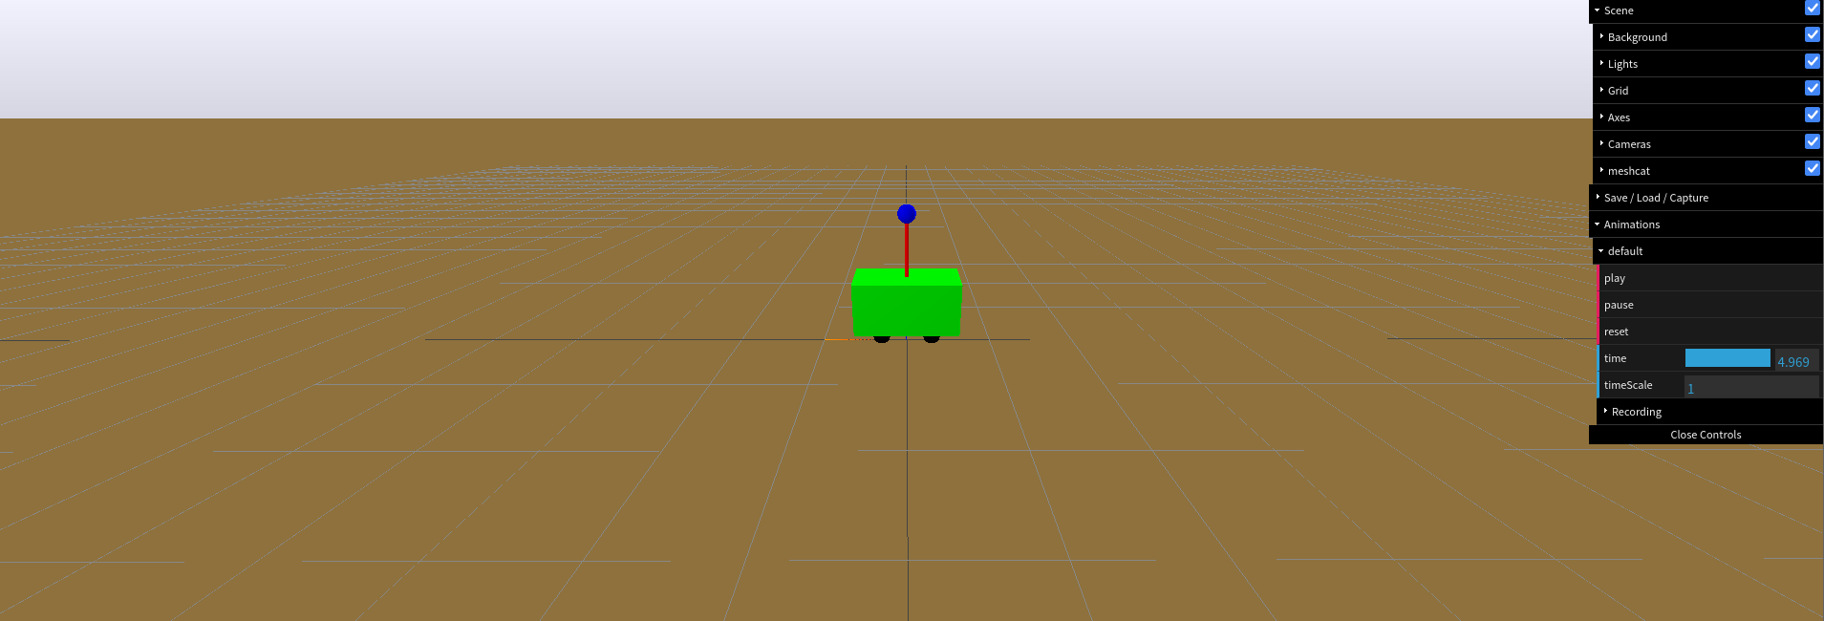 ([GIF file(q5\_0.5pi.gif](q5_0.5pi.gif)) is attached in the document)

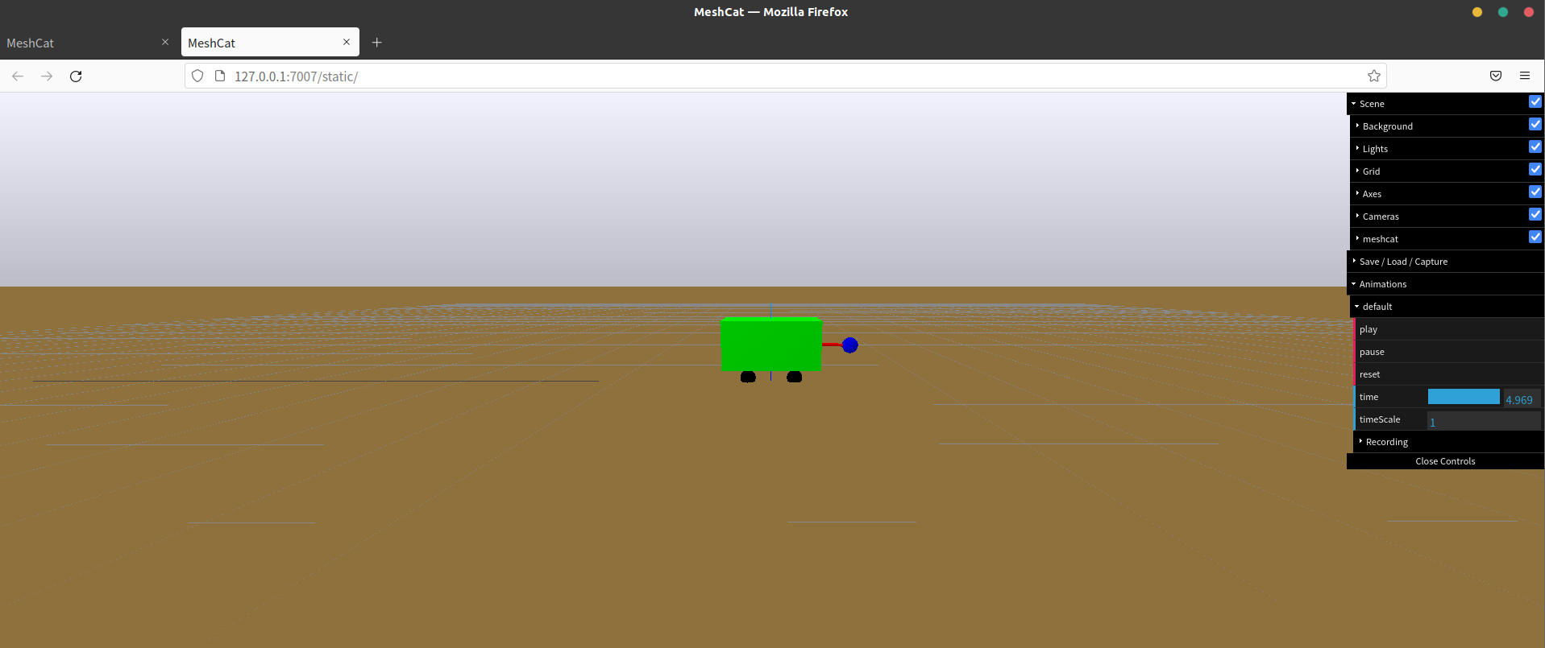

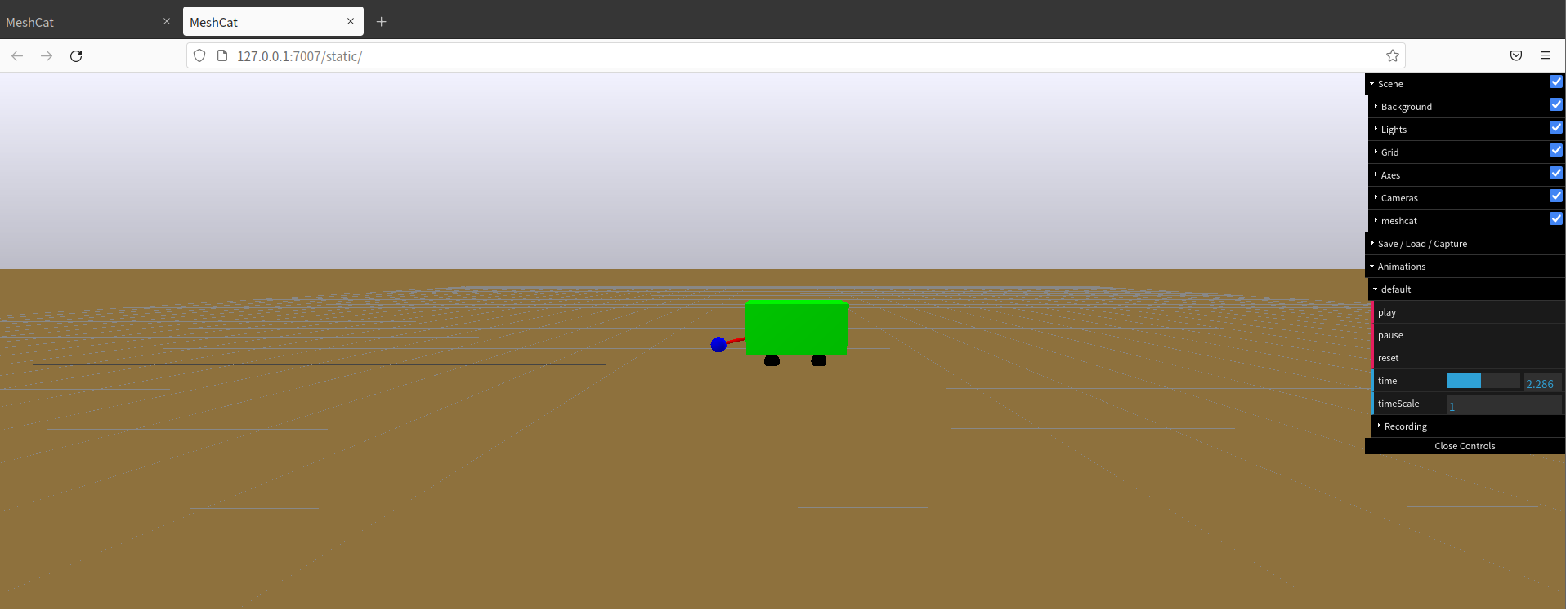

([GIF file(q5\_0.33pi.gif](q5_0.33pi.gif)) is attached in the document)

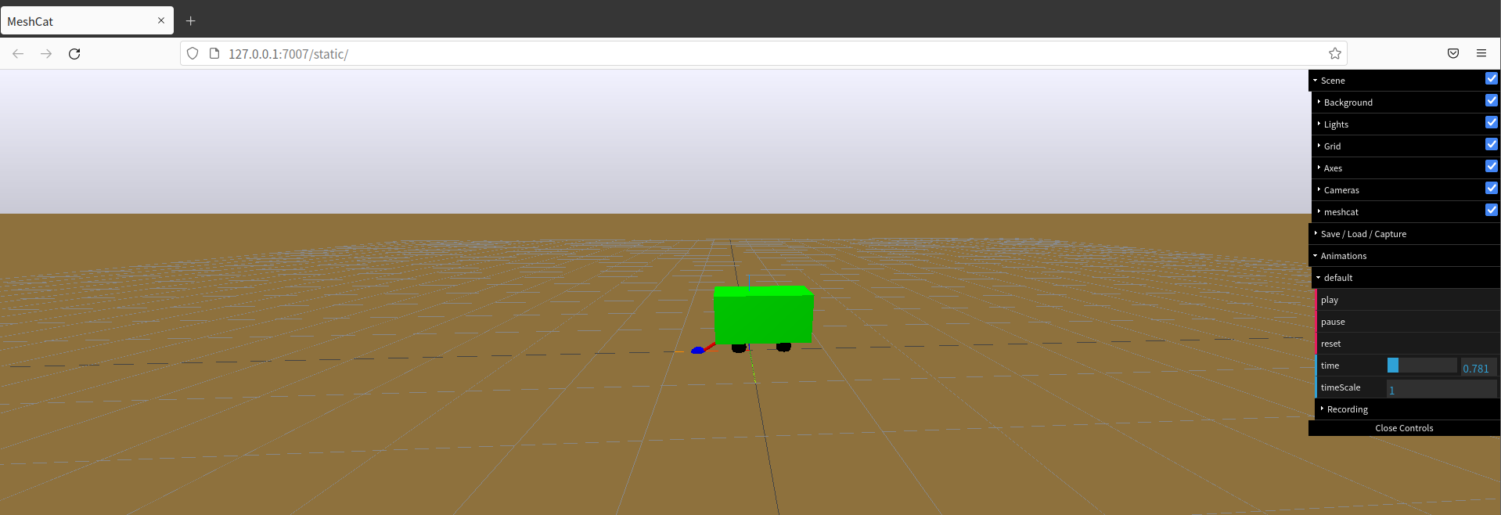

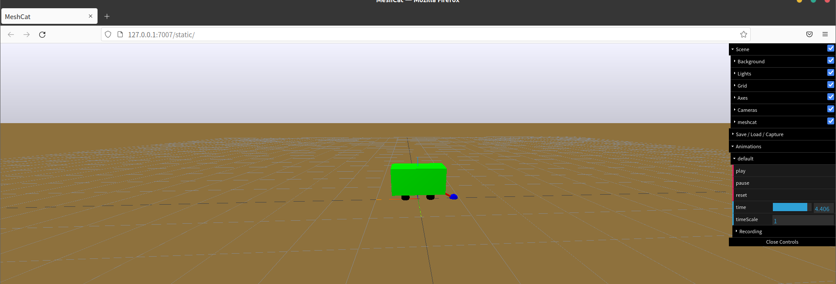

1. **Simulation studies for state-feedback control**
2. **Eigenvalue assignment**

To find K such that A-BK has eigenvalue , where , we should:

The first step:

converting A, B matrices to a python code form:

The matrix shown as below is



The second step:

Calculating Ahat and Bhat matrix based on Part 3.

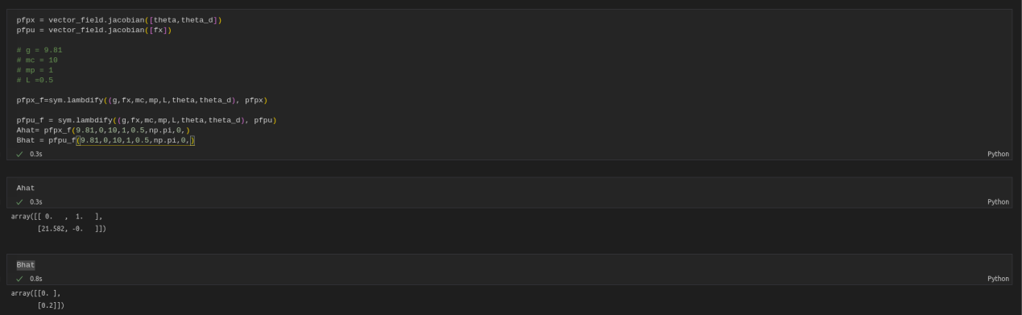

The third step:

Computing the matrix A and the matrix B in Part 4, the form of discrete time angel dynamics model based on the continuous-time linearized model in Part 3.

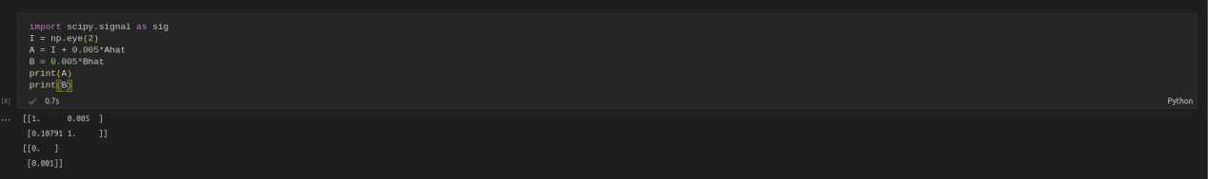

The fourth step:

Applying the function *sig.place\_poles(matrix A, matrix B, z\_desired).gain\_matrix* to find gain K, which leads to the desired eigenvalues of A-BK.

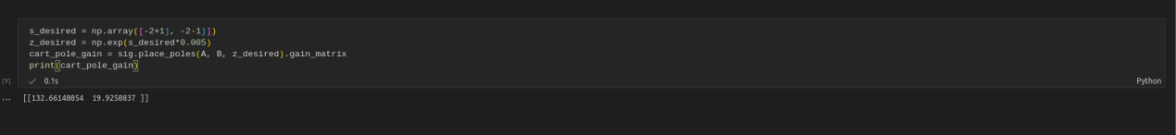

1. **Closed-loop simulation**

After calculating K, we should test the control is feasible or not, or the efficiency of adjustment to stable.

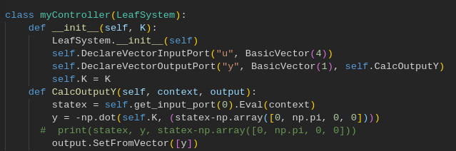

Since K1 and K3 is meant for z, and factor of z could make a difference to , so we prepared 2 sets of K with different K1 and K3.

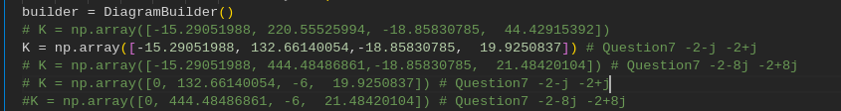

The diagram is shown as below:

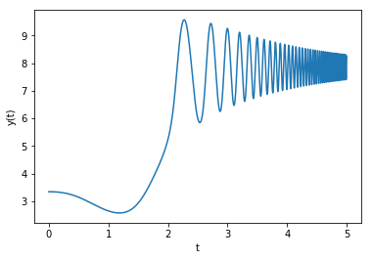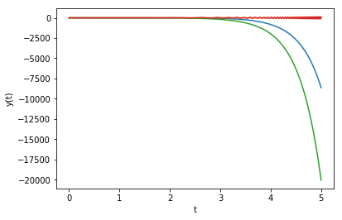

We cans see that diverges.

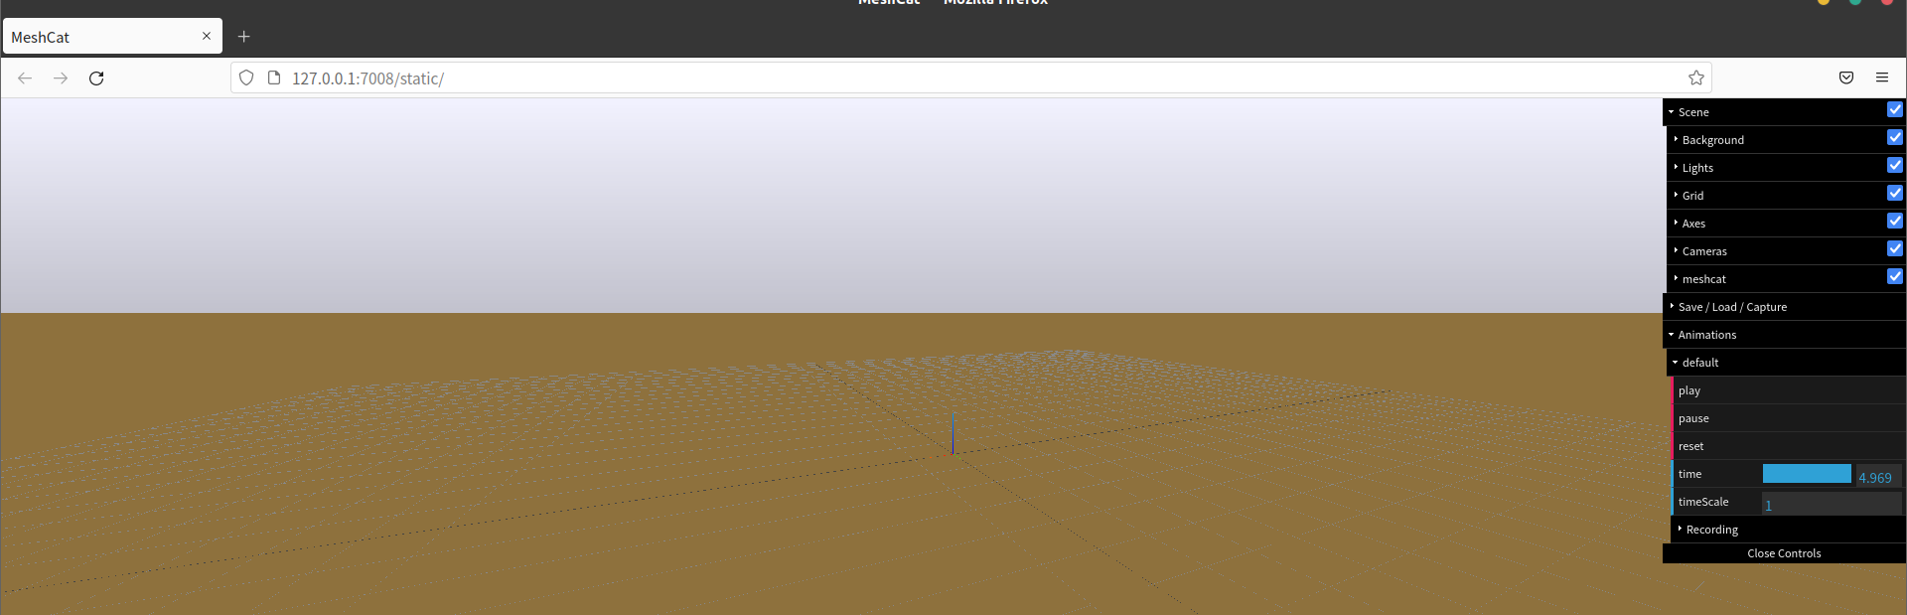

The cart is lost in the simulation, which indicates the failure(seen in<q6b_1.gif>)

We can see that under such conditions, the cart pole is unstable. To eliminate the effect of other factor we used another set of K.

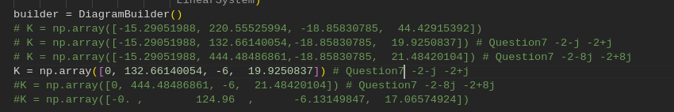

The diagram is shown as below:

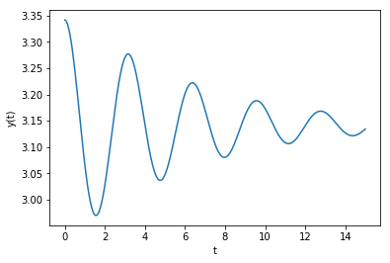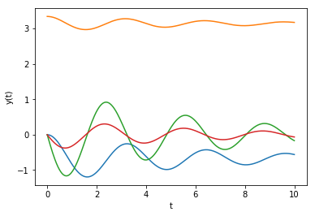

We can see that

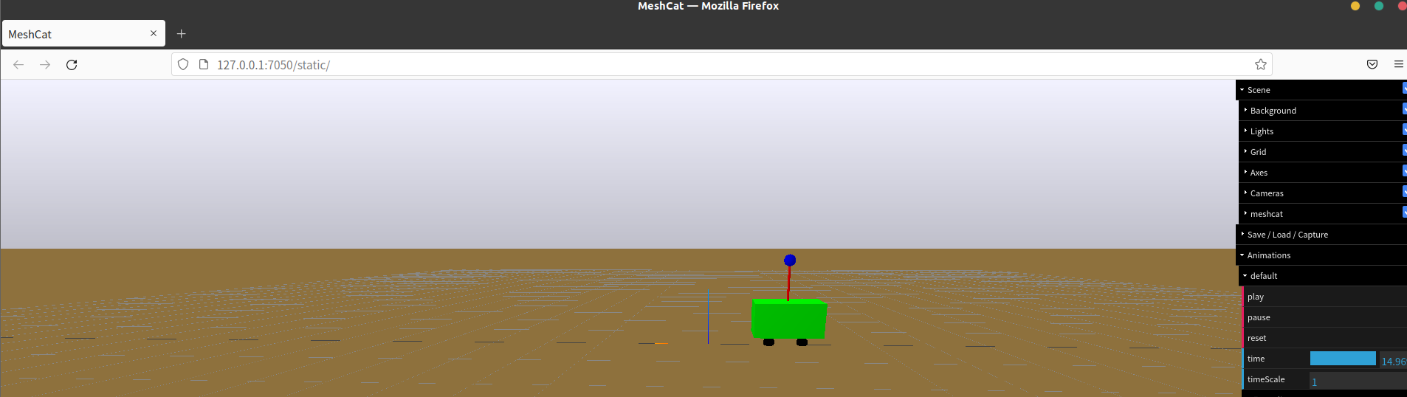

[q6b\_2.gif is attached](q6b_2.gif)

1. **Repeat with different eigenvalues**

First calculate K:

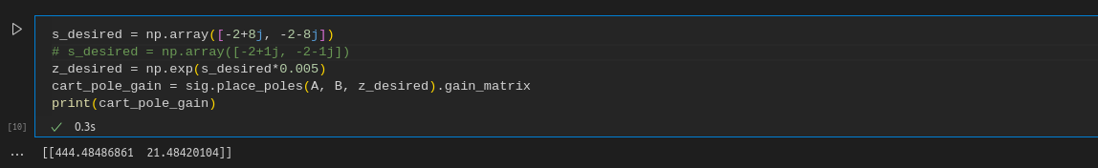

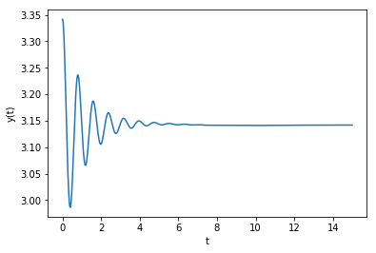 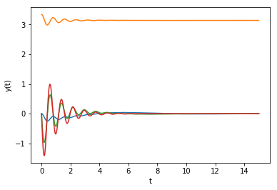

Both converges

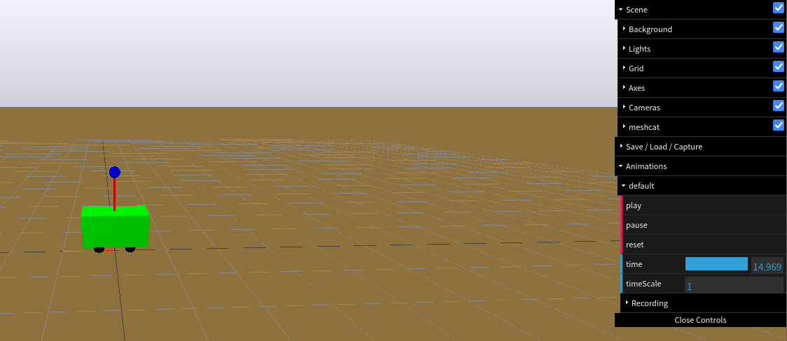

[q7b\_1.gif is attached](q7b_1.gif)

**Analysis:**

Compared with

of eigenvalues =

of takes shorter time to converge to and be in a stable state, which is around 5 second, whose respond is faster.

But for the previous one, it doesn’t show a typically control plotting, and it also converges to a value much larger than . And its ‘s converge time is much more than 5 seconds.

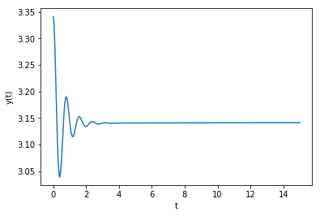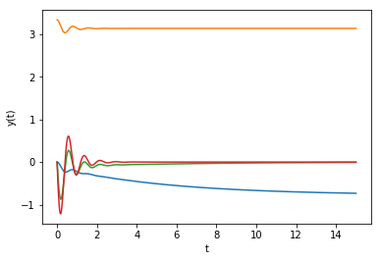

Both converges



[q7b\_2.gif is attached](q7b_2.gif)

**Analysis:**

Compared with

of eigenvalues =

of takes shorter time to converge to and be in a stable state, where the previous one is more than 15 seconds, where the latter is around 2 second, whose respond is faster.

1. **Output feedback control design:**

The code of observer is shown as below:

The first one is to compute L of the specific eigenvalues

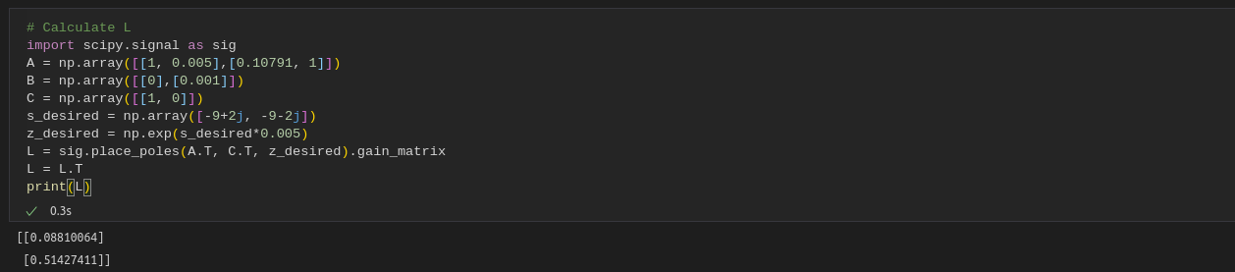

The second one is to set up the model of DT Luenberger observer

**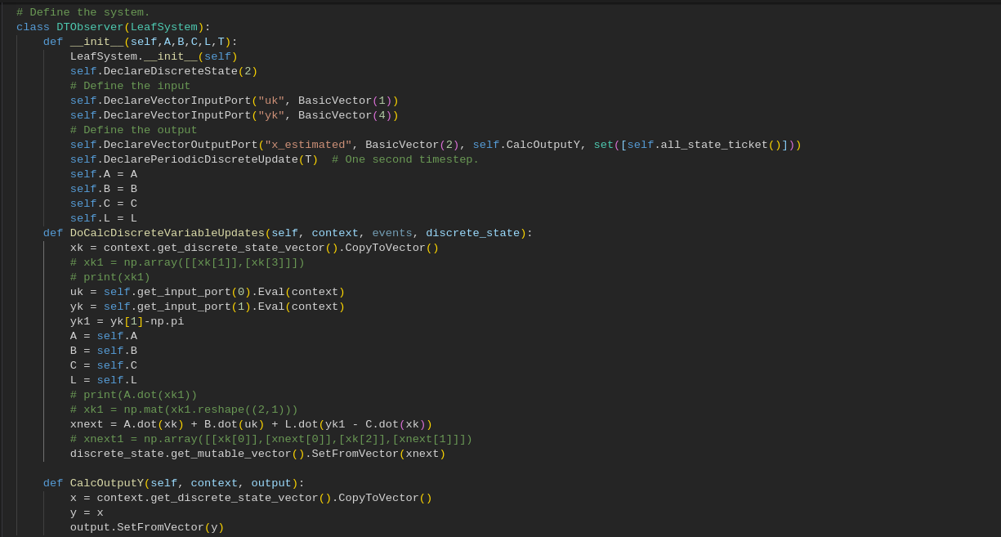**

**Disturbance = 0.2**

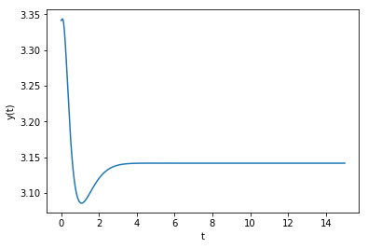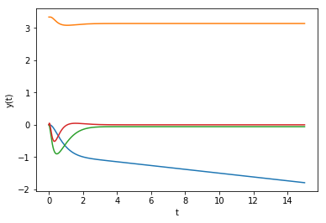

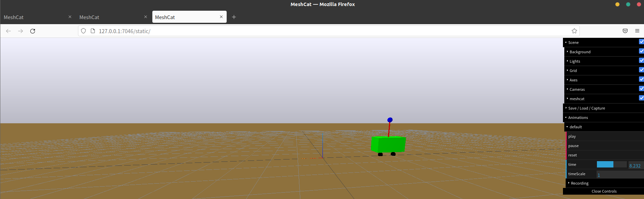

<q81.gif>

**Disturbance = 0.5**

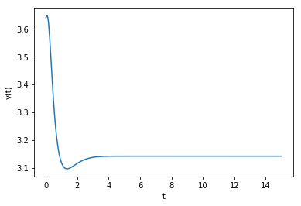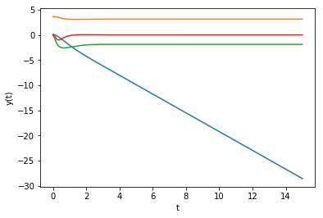



<q82.gif>

**Disturbance = 0.6**

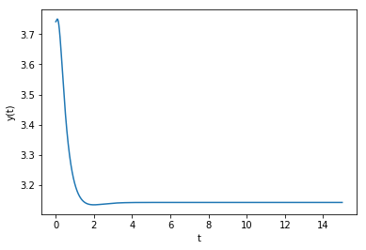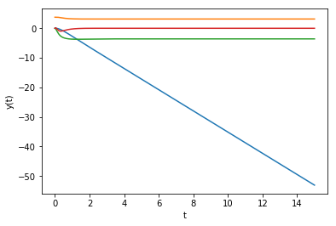

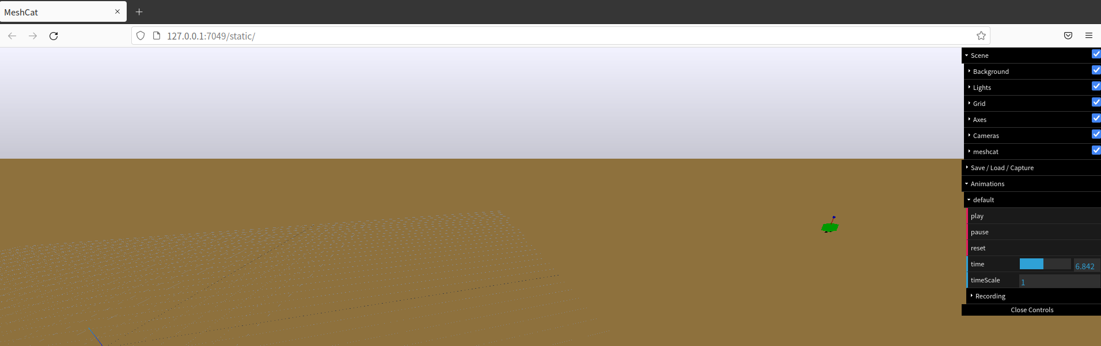

<q83.gif>

**Disturbance = 0.8**

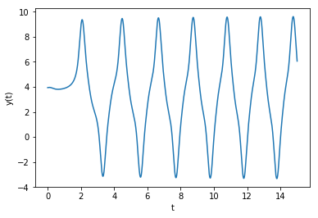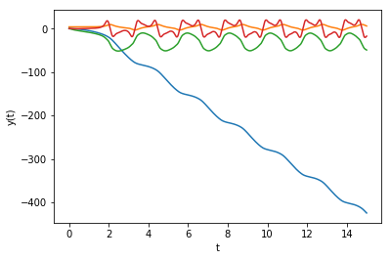

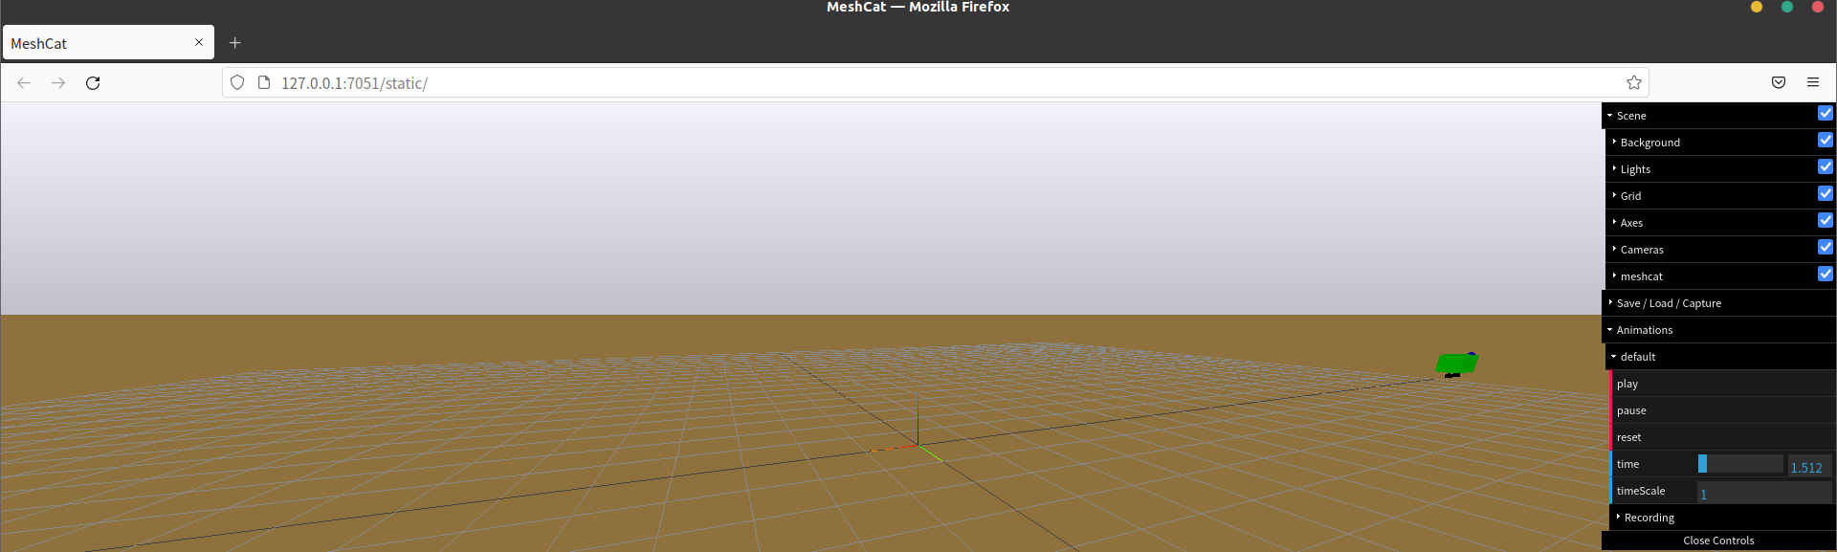

<q84.gif>

We find out that when the initial conditions is in a specific range, the ange of the pole will remain in a stable and desired angle. If the disturbance exceed the range, like the diagrams above when disturbance = 0.8, it may oscillate in a period, and also for z, it will diverge.